**CCT College Dublin**

**Assessment Cover Page**

|  |  |
| --- | --- |
| **Module Title:** | CA2 50% Integrated Assessment |
| **Assessment Title:** | Ireland Construction Data Compared to Other Countries |
| **Lecturer Name:** | David McQuaid |
| **Student Full Name:** | Dornel Duarte Rotta |
| **Student Number:** | 2023066 |
| **Assessment Due Date:** | Friday, 14 April 2023 |
| **Date of Submission:** | Friday, 14 April 2023 |



**Declaration**

|  |
| --- |
| By submitting this assessment, I confirm that I have read the CCT policy on Academic Misconduct and understand the implications of submitting work that is not my own or does not appropriately reference material taken from a third party or other source. I declare it to be my own work and that all material from third parties has been appropriately referenced. I further confirm that this work has not previously been submitted for assessment by myself or someone else in CCT College Dublin or any other higher education institution. |

**Abstract**

*In this study, data from the construction sector in Ireland were analyzed and cross-referenced with countries such as Italy and Germany to discover reasons for the housing crisis that plagues Ireland.*

*Data containing information about Construction Cost, Construction Total, Construction Employment, and population was analyzed and analyzed, summarized their main characteristics, applied statistical data, graphical presentation, and modeled through machine learning.*

*Through this study it was possible to identify that Ireland has an exponential growth in its production costs and, although Italy also shows the same behavior, this may explain why Ireland is in such a housing crisis.*

*By crossing construction data with total population and active population (work force), it was possible to identify that lack of labor is not a problem in Ireland, as it had similar results to its peers in this study.*

*With the addition of machine learning, it was used linear regression and cross validation algorithms to predict how the situation will be if the crisis scenario does not change.*

**Introduction**

The purpose of this study was to analyze construction data from Ireland and compare it with other countries.

For this purpose, Data Analytics concepts were used, such as: Data Business - stage where the business need is evaluated, and the objectives are defined. Data Understanding - phase where the data is analyzed for a complete understanding of how to prepare them, Data Preparation - moment in which the data is selected, structured, and cleaned so that it can be used. Data Visualization - Phase where graphs and dashboards are presented with the desired information. Machine Learning - Step where algorithms are applied to deliver results based on learning, such as predictions, classification, among others.

All this work was prepared using the CRISP-DM project management framework as a basis. Python and its libraries were used as a programming language and tool to carry out the Data Analytics steps. The entire work was managed using GitHub (GitHub, 2023).

**Business Understanding**

The Business Understanding phase focuses on understanding the objectives and requirements of the project. This phase consists basically in determine the business objectives, its necessary first “thoroughly understand, from a business perspective, what the customer really wants to accomplish.” (Data Science Process Alliance, 2023).

The business perspective of this study was analyzing Ireland's Construction data and compare the Irish Construction sector with other countries worldwide.

In this analysis it was expected the inclusion of forecasting, sentiment analysis and evidence-based recommendations for the sector as well as a complete rationale of the entire process used to discover your findings.

It is known which Ireland has been suffering with the cost and lack of house in the last years, based on this topic, it was decided to carry on a work comparing Ireland’s data from total house construction growth and the total house construction cost growth along the time, crossing this data within a depth analysis on the employment rate per total population and total active population.

The main idea was to identify correlations between the increase or decrease in the total number of houses built and its cost with the employment rate in the construction sector as well as with the population growth, not only the absolute total population of a country, but the active (16 years old to 65 years old)) total population. Was the increase or decrease in the total active population a key factor to see an increase in the total cost of houses? The increase or decrease in the employment rate has some impact on the total of houses built?

The countries which were chosen to be compared with Ireland was Italy and Germany. Italy has an older population compared to Ireland and this can bring some interesting comparations about the house data and available work force, on the other hand, Germany has a more productive and active production sector delivering a very good range of different realities to be compared.

**Data Understanding**

This phase of CRISP methodology drives the focus to identify, collect, and analyze the datasets that can help to accomplish the project goals. (Data Science Process Alliance, 2023).

In this step it was collected initial data to be analyzed, this data was described, it means, it was examined and documented its properties like data type, data format, number of records, field identities, and others. Some sort of exploration was done to have a deeper look into the data, printing some recordings and analyzing them, and get some initial answers: How structured was our data available? How clean/dirty was it? Was it necessary to prepare/transform this data? (Data Science Process Alliance, 2023).

## Collect Initial Data

**Acquiring raw data**

Once the data to be collected was defined in the business understanding phase, it was time to start searching for the chosen data:

* Total House Cost Growth along time
* Total House Construction Growth along time
* Construction Employment Rate along time
* Total Population along time
* Total active population along time

The process of acquiring raw data was the most difficult phase in this study, its not easy to find the appropriate set of data, but the main challenge was to find dataset with a free policy to be used.

Searching for datasets with a minimum of organization in data structuring showed that the sites that make them available, for the most part, are paid. Sites like Trading Economics (https://tradingeconomics.com/), CEIC (https://www.ceicdata.com), and Statista (https://www.statista.com/) are good examples, you can easily find the same type of data, for example cost of building houses, this data is available structured in different ways, wide range of periodicity: by year, quarter, or month. Different format values: absolute value, percentage, among other possibilities.

The interesting way found in this study was searching for those datasets on government official websites. Official government sites have no commercial intentions but be prepared to find totally different datasets.

After plenty of time searching appropriated datasets for this work, FRED Economic Data (<https://fred.stlouisfed.org/>) was found. FRED, created and maintained by the Research Department at the Federal Reserve Bank of St. Louis, it’s a dataset repository with a “Copyrighted: Citation required” policy, it means that any dataset can be used since the appropriate citation to FRED website. (FRED, 2023).

Although it was possible to find all the necessary datasets in the FRED website, the “different structure” problem persisted. Each country had its own formatted dataset like different period, different index base, different data type formats, among others, all documented in the next phases of this study.

**Loading raw data**

After the long acquisition process to acquire raw data, the next step was to print a first look on the chosen datasets:

**Total House Construction Cost**

**Ireland**

|  |  |
| --- | --- |
| **Germany** | **Italy** |
|  |  |

After collecting and carrying out a first superficial analysis of the datasets with data on construction house cost, it was already possible to have some first understandings:

- The datasets have different amounts of features (columns).

- Datasets are based on percentage growth with a base year index (info captured on the original source).

- This base year is different in each dataset.

- The start and end dates are different.

- Ireland has annual data, Germany quarterly and Italy monthly data.

**Total House Construction Total**

|  |  |  |
| --- | --- | --- |
| **Ireland** | **Germany** | **Italy** |
|  |  |  |

After collecting and carrying out a first superficial analysis of the datasets with data on total construction house, it was already possible to have some first understandings:

- The datasets have the same number of features (columns).

- Datasets are based on percentage growth with a base year index (info captured on the original source).

- This base year is different in each dataset.

- The start and end dates are different.

- Ireland has quarterly data, Germany monthly data and Italy quarterly data.

**Construction Employment**

|  |  |  |
| --- | --- | --- |
| **Ireland** | **Germany** | **Italy** |
|  |  |  |

After collecting and carrying out a first superficial analysis of the datasets with data on construction employment, it was already possible to have some first understandings:

- The datasets have the same number of features (columns).

- The start dates are different.

- Both datasets have quarterly data.

**Total Population**

|  |  |  |
| --- | --- | --- |
| **Ireland** | **Germany** | **Italy** |
|  |  |  |

After collecting and carrying out a first superficial analysis of the datasets with data on total population, it was already possible to have some first understandings:

- The datasets have the same number of features (columns).

- The start and end dates are the same.

- Both datasets have annual data.

**Total Active Population**

|  |  |  |
| --- | --- | --- |
| **Ireland** | **Germany** | **Italy** |
|  |  |  |

After collecting and carrying out a first superficial analysis of the datasets with data on total active population, it was already possible to have some first understandings:

- The datasets have the same number of features (columns).

- The start dates are different.

- Both datasets have quarterly data.

## Describe and Explore Data

After collecting and taking a first look at the data, in this phase the data was examined and its properties like data format, data type, and number of records were documented. (Data Science Process Alliance, 2023).

The insights collected in this phase were added on the last phase of data understanding: Data Quality Verification.

**Total House Construction Cost**

It was executed other commands to have a better understanding and to be possible to classify the dataset.

Describe: This python function calculates a range of statistical values from our numerical dataset columns. It gives the mean, standard and interquartile values.

|  |  |  |
| --- | --- | --- |
| **Ireland** | **Germany** | **Italy** |
|  |  |  |

Info: This method prints useful information which contains the number of columns, column labels, column data types, number of cells in each column (non-null values).

|  |  |  |
| --- | --- | --- |
| **Ireland** | **Germany** | **Italy** |
|  |  |  |

With these printed values it was possible to document the features of the dataset:

**Ireland**

|  |  |  |  |  |
| --- | --- | --- | --- | --- |
| Feature | Type | Type | Data Type | Null value |
| Statistic | Categorical | N/A | Object | Non-null |
| STATISTIC Label | Categorical | N/A | Object | Non-null |
| TLIST(A1) | Quantitative | Discrete | Int64 | Non-null |
| Year | Quantitative | Discrete | Int64 | Non-null |
| C02196V02652 | N/A | N/A | Object | Non-null |
| State | Categorical | N/A | Object | Non-null |
| Unit | Categorical | N/A | Object | Non-null |
| Value | Quantitative | Discrete | Float64 | Non-null |

**Germany and Italy**

|  |  |  |  |  |
| --- | --- | --- | --- | --- |
| Feature | Type | Type | Data Type | Null value |
| Date | Quantitative | Discrete | Object | Non-null |
| Value | Quantitative | Discrete | Float64 | Non-null |

**Total House Construction**

It was executed other commands to have a better understanding and to be possible to classify the dataset.

Describe: This python function calculates a range of statistical values from our numerical dataset columns. It gives the mean, standard and interquartile values.

|  |  |  |
| --- | --- | --- |
| **Ireland** | **Germany** | **Italy** |
|  |  |  |

Info: This method prints useful information which contains the number of columns, column labels, column data types, number of cells in each column (non-null values).

|  |  |  |
| --- | --- | --- |
| **Ireland** | **Germany** | **Italy** |
|  |  |  |

With these printed values it was possible to document the features of the dataset:

**Ireland, Germany, and Italy**

|  |  |  |  |  |
| --- | --- | --- | --- | --- |
| Feature | Type | Type | Data Type | Null value |
| Date | Quantitative | Discrete | Object | Non-null |
| Value | Quantitative | Discrete | Float64 | Non-null |

**Construction Employment**

It was executed other commands to have a better understanding and to be possible to classify the dataset.

Describe: This python function calculates a range of statistical values from our numerical dataset columns. It gives the mean, standard and interquartile values.

|  |  |  |
| --- | --- | --- |
| **Ireland** | **Germany** | **Italy** |
|  |  |  |

Info: This method prints useful information which contains the number of columns, column labels, column data types, number of cells in each column (non-null values).

|  |  |  |
| --- | --- | --- |
| **Ireland** | **Germany** | **Italy** |
|  |  |  |

With these printed values it was possible to document the features of the dataset:

**Ireland, Germany, and Italy**

|  |  |  |  |  |
| --- | --- | --- | --- | --- |
| Feature | Type | Type | Data Type | Null value |
| Date | Quantitative | Discrete | Object | Non-null |
| Value | Quantitative | Discrete | Float64 | Non-null |

**Total Population**

It was executed other commands to have a better understanding and to be possible to classify the dataset.

Describe: This python function calculates a range of statistical values from our numerical dataset columns. It gives the mean, standard and interquartile values.

|  |  |  |
| --- | --- | --- |
| **Ireland** | **Germany** | **Italy** |
|  |  |  |

Info: This method prints useful information which contains the number of columns, column labels, column data types, number of cells in each column (non-null values).

|  |  |  |
| --- | --- | --- |
| **Ireland** | **Germany** | **Italy** |
|  |  |  |

With these printed values it was possible to document the features of the dataset:

**Ireland, Germany, and Italy**

|  |  |  |  |  |
| --- | --- | --- | --- | --- |
| Feature | Type | Type | Data Type | Null value |
| Date | Quantitative | Discrete | Object | Non-null |
| Value | Quantitative | Discrete | Float64 | Non-null |

**Total Active Population**

It was executed other commands to have a better understanding and to be possible to classify the dataset.

Describe: This python function calculates a range of statistical values from our numerical dataset columns. It gives the mean, standard and interquartile values.

|  |  |  |
| --- | --- | --- |
| **Ireland** | **Germany** | **Italy** |
|  |  |  |

Info: This method prints useful information which contains the number of columns, column labels, column data types, number of cells in each column (non-null values).

|  |  |  |
| --- | --- | --- |
| **Ireland** | **Germany** | **Italy** |
|  |  |  |

With these printed values it was possible to document the features of the dataset:

**Ireland, Germany, and Italy**

|  |  |  |  |  |
| --- | --- | --- | --- | --- |
| Feature | Type | Type | Data Type | Null value |
| Date | Quantitative | Discrete | Object | Non-null |
| Value | Quantitative | Discrete | Float64 | Non-null |

## Explore Data

After data was examined and its properties documented, in this phase it was done a dig deeper into the data. Queried it, visualized it, and identified relationships among the data. (Data Science Process Alliance, 2023).

The main idea here was to plot some initial graphs to have a better understanding of the initial data, the main differences between the datasets, and what was necessary to format/transform/clean during the data preparation phase.

The insights collected in this phase were added on the last phase of data understanding: Data Quality Verification.

**Total House Construction Cost**

Printed a boxplot for every dataset to have a depth look at the distribution of the data. With this graph it was possible to display the distribution of data based on six key values:

* “Minimum”: Disregarding possible outliers
* 1st Quartile (25th percentile)
* Median (2nd Quartile/ 50th Percentile)
* 3rd Quartile (75th percentile)
* “Maximum”: Disregarding possible outliers
* Possible outliers

|  |  |  |
| --- | --- | --- |
| **Ireland** | **Germany** | **Italy** |
|  |  |  |

A first plot of the desired chart type (time series):

|  |  |  |
| --- | --- | --- |
| **Ireland** | **Germany** | **Italy** |
|  |  |  |

**Total House Construction**

Printed a boxplot for every dataset to have a depth look at the distribution of the data. With this graph it was possible to display the distribution of data based on six key values:

* “Minimum”: Disregarding possible outliers
* 1st Quartile (25th percentile)
* Median (2nd Quartile/ 50th Percentile)
* 3rd Quartile (75th percentile)
* “Maximum”: Disregarding possible outliers
* Possible outliers

|  |  |  |
| --- | --- | --- |
| **Ireland** | **Germany** | **Italy** |
|  |  |  |

A first plot of the desired chart type (time series):

|  |  |  |
| --- | --- | --- |
| **Ireland** | **Germany** | **Italy** |
|  |  |  |

**Construction Employment**

Printed a boxplot for every dataset to have a depth look at the distribution of the data. With this graph it was possible to display the distribution of data based on six key values:

* “Minimum”: Disregarding possible outliers
* 1st Quartile (25th percentile)
* Median (2nd Quartile/ 50th Percentile)
* 3rd Quartile (75th percentile)
* “Maximum”: Disregarding possible outliers
* Possible outliers

|  |  |  |
| --- | --- | --- |
| **Ireland** | **Germany** | **Italy** |
|  |  |  |

A first plot of the desired chart type (time series):

|  |  |  |
| --- | --- | --- |
| **Ireland** | **Germany** | **Italy** |
|  |  |  |

**Total Population**

Printed a boxplot for every dataset to have a depth look at the distribution of the data. With this graph it was possible to display the distribution of data based on six key values:

* “Minimum”: Disregarding possible outliers
* 1st Quartile (25th percentile)
* Median (2nd Quartile/ 50th Percentile)
* 3rd Quartile (75th percentile)
* “Maximum”: Disregarding possible outliers
* Possible outliers

|  |  |  |
| --- | --- | --- |
| **Ireland** | **Germany** | **Italy** |
|  |  |  |

A first plot of the desired chart type (time series):

|  |  |  |
| --- | --- | --- |
| **Ireland** | **Germany** | **Italy** |
|  |  |  |

**Total Active Population**

Printed a boxplot for every dataset to have a depth look at the distribution of the data. With this graph it was possible to display the distribution of data based on six key values:

* “Minimum”: Disregarding possible outliers
* 1st Quartile (25th percentile)
* Median (2nd Quartile/ 50th Percentile)
* 3rd Quartile (75th percentile)
* “Maximum”: Disregarding possible outliers
* Possible outliers

|  |  |  |
| --- | --- | --- |
| **Ireland** | **Germany** | **Italy** |
|  |  |  |

A first plot of the desired chart type (time series):

|  |  |  |
| --- | --- | --- |
| **Ireland** | **Germany** | **Italy** |
|  |  |  |

## Data Quality Verification

After data depth explored, in this last phase of the Data Understanding, it was the moment to summarize the data quality and answer some questions to define the final information: Which features are useful? Which ones need to be removed? Did the data need to be transformed? Does the data need to be cleaned? Among others? (Data Science Process Alliance, 2023).

A total of 15 datasets were used in this study to accomplish the necessary visualizations. These datasets contained data about 5 main topics:

* Total House Construction Cost growth
* Total Construction Growth
* Construction Employment
* Total Population
* Total Active Population (16 – 65 years old)

After an initial collection and exploration phase, it was found a considerable number of differences in how the data was fitted in those datasets:

|  |  |  |  |  |
| --- | --- | --- | --- | --- |
| Total House Construction Cost | | | | |
| Country | **Data type** | **Range** | **Index base** | **Time series** |
| Ireland | Percentage | 1975 – 2016 | Jan/1991 | Annually |
| Germany | Percentage | 1960 – 2022 | 2015 | Quarterly |
| Italy | Percentage | 1967 – 2023 | 2015 | Monthly |

|  |  |  |  |  |
| --- | --- | --- | --- | --- |
| Total House Construction | | | | |
| Country | **Data type** | **Range** | **Index base** | **Time series** |
| Ireland | Percentage | 2001 – 2022 | Growth rate same period previous year | Quarterly |
| Germany | Percentage | 1962 – 2023 | 2015 | Monthly |
| Italy | Percentage | 1995 – 2022 | 2015 | Quarterly |

|  |  |  |  |  |
| --- | --- | --- | --- | --- |
| Construction Employment | | | | |
| Country | **Data type** | **Range** | **Index base** | **Time series** |
| Ireland | Quantity | 1998 – 2022 | N/A | Quarterly |
| Germany | Quantity | 2005 – 2022 | N/A | Quarterly |
| Italy | Quantity | 1998 – 2022 | N/A | Quarterly |

|  |  |  |  |  |
| --- | --- | --- | --- | --- |
| Total Population | | | | |
| Country | **Data type** | **Range** | **Index base** | **Time series** |
| Ireland | Quantity | 1960 – 2021 | N/A | Annually |
| Germany | Quantity | 1960 – 2021 | N/A | Quarterly |
| Italy | Quantity | 1960 – 2021 | N/A | Quarterly |

|  |  |  |  |  |
| --- | --- | --- | --- | --- |
| Total Active Population | | | | |
| Country | **Data type** | **Range** | **Index base** | **Time series** |
| Ireland | Quantity | 1999 – 2022 | N/A | Quarterly |
| Germany | Quantity | 2005 – 2022 | N/A | Quarterly |
| Italy | Quantity | 1998 – 2022 | N/A | Quarterly |

What needs to be done during the data preparation phase?

* Remove features that are not useful.
* Rename features to have a friendlier name and be easier to identify.
* Adjust date range so that all datasets start and end in the same year.
* Adjust the date period, some datasets are annual, other monthly and other quarterly, adjust so that all have the same period.
* Standardize the base index of the data period, some datasets have base index in the year 2005, others 2015, others in 1991.
* Format data types by converting to the correct type. Example: Type object for float, type object for date, string for integer...
* Round on values with many decimal places.
* Readjust columns/rows (pivot) according to the desired chart type.
* Concatenate datasets with the same data pattern. Example: Construction Cost can be the same dataset for Ireland, Germany, and Italy instead of each country having its own dataset.

**Data Preparation**

This phase prepares raw data to be suitable for further processing and analysis. Key steps include cleaning, constructing/transforming data, integrating/merging datasets, and formatting data. (Data Science Process Alliance, 2023)

## Data Cleaning

The first step of data preparation was to clean the datasets. This process included removing useless features and removing differences in the range period.

**House Construction Cost**

Since the focus of this study was to analyze only the increase in the cost of houses, it was only necessary to maintain data referring to the period (Year) and the growth value (VALUE), the other features do not have relevant value.

Features removed from Ireland Dataset:

* STATISTIC
* STATISTIC Label
* TLIST(A1)
* C02196V02652
* UNIT
* State

The common date period between the datasets was preserved, removing other lines beyond the range between 1975 - 2016

|  |  |  |  |  |
| --- | --- | --- | --- | --- |
| Total House Construction Cost | | | | |
| Country | **Data type** | **Range** | **Index base** | **Time series** |
| Ireland | Percentage | 1975 – 2016 | Jan/1991 | Annually |
| Germany | Percentage | 1960 – 2022 | 2015 | Quarterly |
| Italy | Percentage | 1967 – 2023 | 2015 | Monthly |

**House Construction Cost**

Since the focus of this study was to analyze only the increase in the cost of houses, it was only necessary to maintain data referring to the period (Year) and the growth value (VALUE), the other features do not have relevant value.

Features removed from Ireland Dataset (Germany and Italy datasets didn’t have extra features):

* STATISTIC
* STATISTIC Label
* TLIST(A1)
* C02196V02652
* UNIT
* State

The common date period between the datasets was preserved, removing other lines beyond the range between 1975 – 2016:

|  |  |  |  |  |
| --- | --- | --- | --- | --- |
| Total House Construction Cost | | | | |
| Country | **Data type** | **Range** | **Index base** | **Time series** |
| Ireland | Percentage | 1975 – 2016 | Jan/1991 | Annually |
| Germany | Percentage | 1960 – 2022 | 2015 | Quarterly |
| Italy | Percentage | 1967 – 2023 | 2015 | Monthly |

**Total Construction**

The initial dataset form of each country had the same number of features, Date and Value, in this case, it was only necessary to clean the date period difference between the datasets.

To keep the same range of House Cost, It was removed other lines beyond the range between 1975 – 2016:

|  |  |  |  |  |
| --- | --- | --- | --- | --- |
| Total House Construction | | | | |
| Country | **Data type** | **Range** | **Index base** | **Time series** |
| Ireland | Percentage | 2001 – 2022 | Growth rate same period previous year | Quarterly |
| Germany | Percentage | 1962 – 2023 | 2015 | Monthly |
| Italy | Percentage | 1995 – 2022 | 2015 | Quarterly |

**Construction Employment**

The initial dataset form of each country had the same number of features, Date and Value, in this case, it was only necessary to clean the date period difference between the datasets.

It was removed other lines beyond the range between 2005 – 2022:

|  |  |  |  |  |
| --- | --- | --- | --- | --- |
| Construction Employment | | | | |
| Country | **Data type** | **Range** | **Index base** | **Time series** |
| Ireland | Quantity | 1998 – 2022 | N/A | Quarterly |
| Germany | Quantity | 2005 – 2022 | N/A | Quarterly |
| Italy | Quantity | 1998 – 2022 | N/A | Quarterly |

**Total Population**

The initial dataset form of each country had the same number of features, Date and Value, in this case, it was only necessary to clean the date period difference between the datasets.

It was removed other lines beyond the range between 2005 – 2022:

|  |  |  |  |  |
| --- | --- | --- | --- | --- |
| Total Population | | | | |
| Country | **Data type** | **Range** | **Index base** | **Time series** |
| Ireland | Quantity | 1960 – 2021 | N/A | Annually |
| Germany | Quantity | 1960 – 2021 | N/A | Quarterly |
| Italy | Quantity | 1960 – 2021 | N/A | Quarterly |

**Total Active Population**

The initial dataset form of each country had the same number of features, Date and Value, in this case, it was only necessary to clean the date period difference between the datasets.

It was removed other lines beyond the range between 2005 – 2022:

|  |  |  |  |  |
| --- | --- | --- | --- | --- |
| Total Active Population | | | | |
| Country | **Data type** | **Range** | **Index base** | **Time series** |
| Ireland | Quantity | 1999 – 2022 | N/A | Quarterly |
| Germany | Quantity | 2005 – 2022 | N/A | Quarterly |
| Italy | Quantity | 1998 – 2022 | N/A | Quarterly |

## Constructing / Transforming Data

Once the features and lines of the datasets have been cleaned, in this phase some transformations are performed to adapt the data.

The datasets of the countries have data referring to the period in different presentations, such as monthly, quarterly, and annual.

The first transformation was to standardize all datasets to contain an annualized period.

For datasets with monthly or quarterly values, only the lines referring to the last value of the year were maintained. Quarterly: month 10. Monthly: month 12.

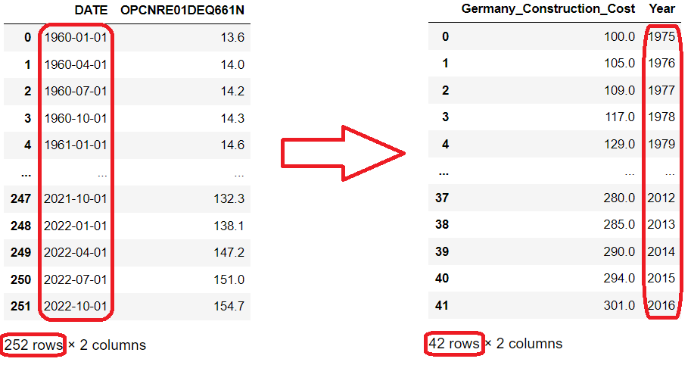

After this step, the most important transformation of this phase was performed, since there were datasets with different indexes, for example, in one the index refers to the year 2005, in another one it refers to the year 1991, to keep them all in the same pattern, the base index was recalculated to be the first record, starting at 100.

For example, a dataset that had the base index in the year 2015 was recalculated to have the base index in the year 1975 (first line).

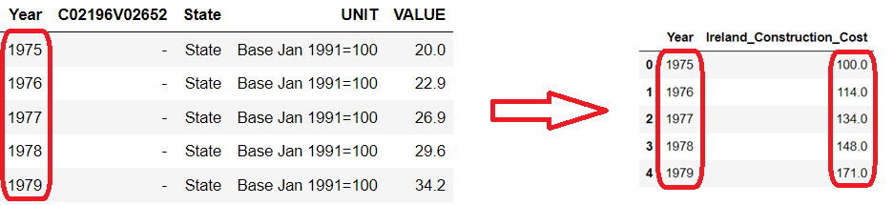

Another important transformation was related to the structure of the dataset to facilitate the plot depending on the type of graph desired.

To this end, the datasets have had their columns restructured into rows:

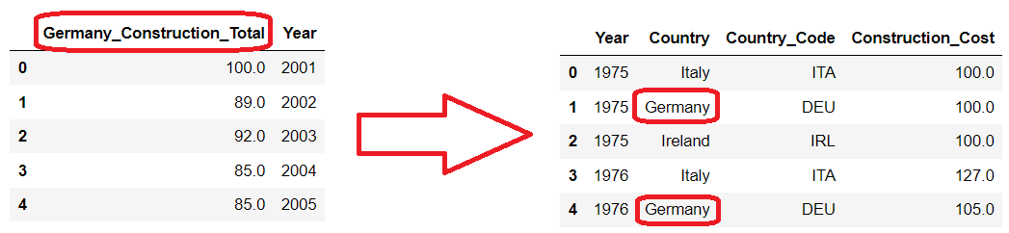

## Formatting Data

Features were renamed to have a more friendly name and be easier to identify.

Data types were formatted by converting to the correct type. Example: Type object for float, type object for date, string for integer.

Values with many decimal places were rounded.

## Integrating Data

In this last step of data preparation, datasets with the same data type were concatenated.

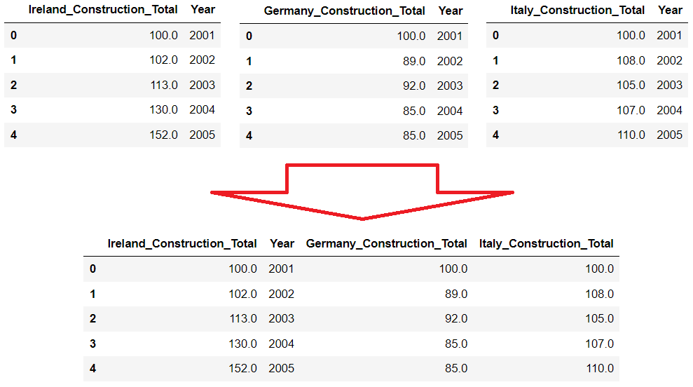

**Data Visualization**

The purpose of this study was to analyze construction data from Ireland and compare it with other countries.

Ireland construction data was crossed per population and compared to the same type of data from Italy and Germany with a focus to try to identify some insights of house cost crisis in Ireland.

The chosen color for the graph lines were the set of 3 colors that go great together according with Adobe – “The right or wrong three-color combination can boost your message, detract from it, or even twist it to mean something else entirely”: (Adobe, 2023).

* Yellow, red, and blue
* Green, orange, and purple
* **Teal, magenta, and gold (elected)**

## House Construction Cost

This first graphic plot shows data about House Construction Cost compared between the three countries of this study: Ireland, Germany, and Italy.

The period starts from 1975 to 2016 and shows the cost increase year by year starting from a base index of 100 in 1975.

It is possible to analyze which Ireland and Italy had a similar pattern of growth in its numbers, where Italy has finished with almost 12 times (1,173%) the cost rate compared to 1975 and Ireland has finished with just over 10 times (1,041%) the cost rate compared to 1975.

Surprisingly, Germany increased by far less than Ireland and Italy, only three times (301%) more compared with 1975.

Ireland has a housing crisis greater than its peers in the graph, the exponential growth in house construction costs could explain the reason for such a crisis, however when verifying that Italy had an explosion in its costs even more intense than Ireland, it is surprising that there the crisis is not so alarming.

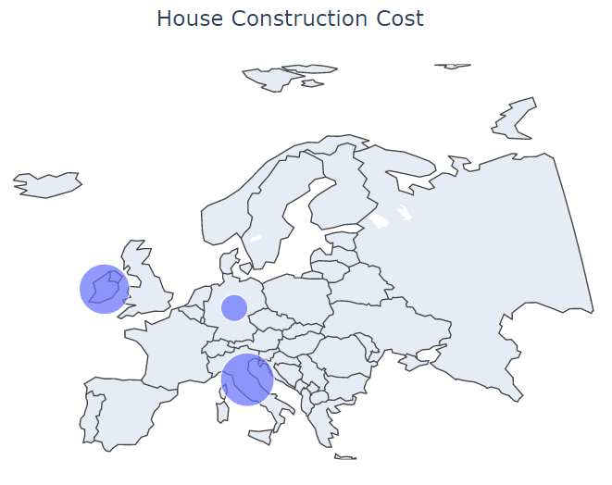

## House Construction Total

This graphic plot shows data about house total construction compared between the three countries of this study: Ireland, Germany, and Italy.

The period starts from 2001 to 2022 and shows the total construction increase/decrease year by year starting from a base index of 100 in 2001.

Ireland shows the highest increase and decrease in its numbers over the years, with a peak growth of 153% in 2006 and ending in 2022 with only 53% of the total construction it had in 2001.

Germany was the only country that ended 2022 with an increase, with a growth of 134% after a slight drop between 2001 and 2010.

Italy had a growth throughout the 2000s reaching its peak of 121% in 2006 and then showing a decline throughout the 2010s with its lowest figure being 70% in 2014, 2015 and 2016, closing the year 2022 with an almost total 95% recovery.

This large drop of around 50% in its total home construction combined with the very high cost of construction is a strong indication of why the housing crisis is greater in Ireland than its peers.

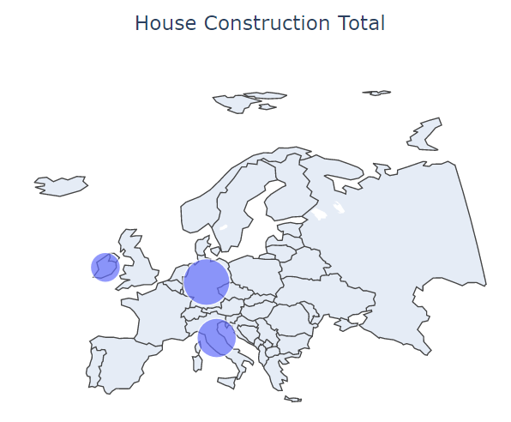

## Construction Employment

This graphic plot shows data about house total construction employment compared between the three countries of this study: Ireland, Germany, and Italy.

The period starts from 2005 to 2022 and shows the total number of people employed in construction year by year.

Since this graph only presents the absolute numbers of the population employed in the construction area, it is not possible to carry out extensive analyses. In the next graphs, values will be crossed with the total absolute and active population, where we will have the average per 1000 for a better comparative conclusion.

## Construction Employment per Total Population

This graphic plot shows data about construction employment per total population compared between the three countries of this study: Ireland, Germany, and Italy.

By applying the concept of the per 1000 rate (Construction employment / Population * 1000), It was possible to have a more realistic view of the difference between Ireland and its peers in the graph, since countries have very different total population numbers.

Ireland is the country that presented the greatest variations, being mainly represented by a vertiginous drop from a peak of 66 in 2006 to 18 workers per 1000 inhabitants in 2012, probably very affected by the subprime crisis in the United States. After 2012, Ireland began to recover, ending 2022 with around 30 workers.

It was interesting to note that Italy and Germany had little impact regarding the 2008 crisis, with only Italy having a drop from 33 in 2007 to 22 workers in 2019, showing a recovery only from 2020 ending 2022 with 25 workers.

Another surprise was that despite a huge drop of almost 400%, Ireland ended 2022 at the same level as Germany and above Italy.

It was expected that Ireland would have a supposed labor deficit to explain the housing crisis, it is likely that this crisis reflects earlier years and perhaps Ireland should have followed with twice the levels of construction and labor as their peers, keeping values equal to countries that have fewer housing crisis problems will only keep the crisis stabilized.

## Construction Employment per Active Population

This graphic plot shows data about construction employment per active population compared between the three countries of this study: Ireland, Germany, and Italy.

By applying the concept of the per 1000 rate (Construction employment / Active Population * 1000), it was possible to have a more realistic view of the difference between Ireland and its peers in the graph, since countries have very different total population numbers.

Compared with the previous graph, a similar behavior is perceived in the variations, with a surprise where the three countries ended 2022 with a technical tie in the number of workers. This is because Italy has an older population than its peers.

Even crossing the data of workers by active population, Ireland continues with similar results and the conclusion drawn by the previous graph also applies.

**Statistical Analysis - Hypothesis**

In this study, four different hypothesis tests were performed, two parametric and two non-parametric. Two variables were tested for each hypothesis test, totaling eight tests performed.

Variables tested:

* Construction Total
* Construction Cost

Each variable represents data from different countries:

* Ireland
* Germany
* Italy

Parametric tests used:

* ANOVA.
* Tukey-Kramer.

Non-parametric tests used:

* The Kruskal-Wallis Test
* The Mann Whitney U test

## Parametric Tests

**Construction Total**

To perform the parametric test the ANOVA and Tukey-Kramer was performed.

The dataset used contained data about total construction from tree countries (Ireland, Germany, and Italy):

On Jupiter notebook in the session “Statistical Analysis” all the code to prepare the data and perform the test is found.

Results processing ANOVA:

F_onewayResult:

* Statistic = 8.077087382551689
* Pvalue = 0.0007538792784005494

p-value was a very small value (close to zero), which means reject (H0) at least mu is different.

A plot to see why we have rejected H0:

It was processed a Tukey-Kramer analysis to understand which the means differed from each other’s.

On Jupiter notebook in the session “Statistical Analysis” all the code to prepare the data and perform the test is found.

Results of Tukey-Kramer:

There is difference between Germany and Ireland in terms of Construction Total mean, then it is possible to reject H0 (reject = True).

There is not enough evidence that there is difference between Germany and Italy in terms of Construction Total mean (reject = False).

There is not enough evidence that there is difference between Ireland and Italy in terms of Construction Total mean (reject = False).

**Construction Cost**

To perform the parametric test the ANOVA and Tukey-Kramer was performed.

The dataset used contained data about construction cost from tree countries (Ireland, Germany, and Italy):

On Jupiter notebook in the session “Statistical Analysis” all the code to prepare the data and perform the test is found.

Results processing ANOVA:

F_onewayResult:

* Statistic = 43.385193126897114
* Pvalue = 5.519470467860248e-15

p-value was a very small value (close to zero), which means reject (H0) at least mu is different.

A plot to see why we have rejected H0:

It was processed a Tukey-Kramer analysis to understand which the means differed from each other’s.

On Jupiter notebook in the session “Statistical Analysis” all the code to prepare the data and perform the test is found.

Results of Tukey-Kramer:

There is difference between Germany and Ireland in terms of Construction Cost mean, then it is possible to reject H0 (reject = True).

There is difference between Germany and Italy in terms of Construction Cost mean, then it is possible to reject H0 (reject = True).

There is not enough evidence that there is difference between Ireland and Italy in terms of Construction Cost mean (reject = False).

## Non-Parametric

**Construction Total**

To perform the non-parametric tests the The Kruskal-Wallis Test and The Mann Whitney U test was performed.

The dataset used contained data about total construction from tree countries (Ireland, Germany, and Italy):

On Jupiter notebook in the session “Statistical Analysis” all the code to prepare the data and perform the test is found.

Results processing **Kruskal-Wallis**:

* Statistic = 12.489949944361493
* p-value = 0.0019401791356987443

In this case, the test statistic is 12.489949944361493 and the corresponding p-value is 0.0019401791356987443. Since this p-value is less than 0.05, we can reject the null hypothesis. We have sufficient evidence to conclude that the Construction Total leads to statistically significant differences in the tested countries.

Results processing **The Mann Whitney U test**:

* Statistic = 141.0
* p-value = 0.0172428358815674

In this case, the test statistic is 141.0 and the corresponding p-value is 0.0172428358815674. As the p-value obtained is significant (p < 0.05), It was concluded that the Construction Total between Ireland and Italy is significantly different from each other.

**Construction Cost**

To perform the non-parametric tests the The Kruskal-Wallis Test and The Mann Whitney U test was performed.

The dataset used contained data about total construction from tree countries (Ireland, Germany, and Italy):

On Jupiter notebook in the session “Statistical Analysis” all the code to prepare the data and perform the test is found.

Results processing **Kruskal-Wallis**:

* Statistic = 51.12795478931108
* p-value = 7.901429727579382e-12

In this case, the test statistic is 51.12795478931108 and the corresponding p-value is 7.901429727579382e-12. The p-value is greater than 0.05. The null hypothesis is thus retained, and it is assumed that there is no difference between the different groups in terms of reaction time.

Results processing **The Mann Whitney U** test:

* Statistic = 735.0
* p-value = 0.1910282993261464

In this case, the test statistic is 735.0 and the corresponding p-value is 0. 0.1910282993261464. As the p-value obtained is significant (p < 0.05), It was concluded that the Construction Cost between Ireland and Italy is significantly different from each other.

**Modeling and Evaluation - Machine Learning**

## Linear Regression

Linear regression performs the task to predict a dependent variable(target) based on the given independent variable(s). So, this regression technique finds out a linear relationship between a dependent variable and the other given independent variables (Analytics Vidhya, 2022).

With a wide range of algorithms options to use linear regression, in this work it was tried three different options:

* Time Step Feature.
* Lag Feature.
* Multi Featured (one dependent, n independent).

In both types it was used the same approach that consisted in predict the house construction cost for the three countries of this work: Ireland, Germany, and Italy:

## Time Step Feature

The basic object of forecasting is the time series, which is a set of observations recorded over time. In forecasting applications, the observations are typically recorded with a regular frequency, like daily or monthly (Kaggle, 2021).

Time-step features are features which can be derived directly from the time index. The most basic time-step feature is the time dummy, which counts off time steps in the series from beginning to end (Kaggle, 2021).

Once the dataset has yearly data, the dummy value was calculated based on this date value:

Next step was separate the prepared data to use in the predictive algorithm, the dummy value represented by “Time” was the independent feature and House Construction Cost was the target (dependent feature):



The time-step value represented by XT:

After separate the training data, it was time to train the model and get the results:

The results plotted per country:

The graphs showed the predictive line (in blue) vs the real data.

|  |  |  |
| --- | --- | --- |
| **Model Coefficient** | | |
| **Ireland** | **Germany** | **Italy** |
| 25.69 | 4.47 | 26.74 |

The coefficient signifies the amount by which change in x must be multiplied to give the corresponding average change in y, or the amount y changes for a unit increase in x (The BMJ, 2023).

|  |  |  |
| --- | --- | --- |
| **Model Intercept** | | |
| **Ireland** | **Germany** | **Italy** |
| 97.50 | 115.56 | 169.74 |

The intercept value shows the point where the estimated regression line crosses the 𝑦 axis. It's the value of the estimated response 𝑓(𝑥) for 𝑥 = 0. This value determines the slope of the estimated regression line (The BMJ, 2023).

Based on the results this model, it was possible to predict the future values:

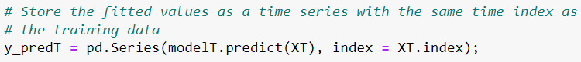

How to predict using time-step?

This dataset had 42 time series representing years from 1975 to 2016, any number from 43 will predict new values for House Construction Cost, for example:

# 42 = 2017

# 43 = 2018

# 46 = 2021

# 50 = 2025:

49 = 01/2023

50 = 02/2023

56 = 08/2023

60 = 12/2023

Sample for Ireland:





Analyzing the results, it was possible to verify the following points:

* A larger coefficient indicates a better fit and means that the model can better explain the variation of the output with different inputs (Machine Learning Mastery, 2019)
* The predicted line of predicted values fitted with real values on the graph.

## Lag Feature

In the lag feature type, it was shifted the observations of the target series, in this case the Total Construction Cost, so that appeared to have occurred later in time. In this example it was created a 1-step lag feature.

The first step, as previously mentioned, it was shifted the value of the target feature, now the data frame has a Total and previous Total value added as a new column “Lag_1”:



Data frame:

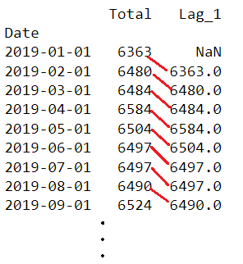

The previous Total value was shifted as a new feature, but a null value was found because for the first row didn’t have a previous value, so it was necessary to remove this line using the *dropna* function and align dropping the correspondent values in target:

And the model was trained:

Results plotted from country:

|  |  |  |
| --- | --- | --- |
| **Ireland** | **Germany** | **Italy** |
|  |  |  |

|  |  |  |
| --- | --- | --- |
| **Model Coefficient** | | |
| **Ireland** | **Germany** | **Italy** |
| 0.98 | 0.98 | 0.97 |

data.

|  |  |  |
| --- | --- | --- |
| **Model Intercept** | | |
| **Ireland** | **Germany** | **Italy** |
| 32.15 | 7.87 | 41.76 |

Analyzing the results, it was possible to verify the following points:

* A larger coefficient indicates a better fit and means that the model can better explain the variation of the output with different inputs (Machine Learning Mastery, 2019)
* The predicted line of predicted values fitted with real values on the graph.

## Train Test Split: Multi Featured (Reduced Data)

In this algorithm it was used the same previous system, but with the difference that it was used more than two independent variables.

Construction Employment and Active Population (wok force) was added to work together with House Construction Cost and Year on this algorithm.

Year, Construction Employment and Active Population as X, and Construction Cost as target variable?



Predictions:

Results:

It was not possible to prove a correction between house construction cost, employment, and active population.

Large changes in the values of the independent variables (employment and active population) represented timid and insufficient changes in the target variable house construction cost.

Probably the year variable has a greater influence on the predicted results than the others.

Another important factor is the dataset with small amount of data, which makes it difficult for this split training data algorithm to have good results.

## Cross Validation with Linear Regression

To test this data with cross validation with linear regression it was separated data about Construction Total and Population Total from Germany, both represented yearly:

The first step was necessary to change the scale of the main variables to fit in the algorithm:

Resulting in:

Visualization of Construction Total-Population relationship:

After preparing the data, next step was to split:

Reshaping was required since sklearn requires the data to be in shape:

Finally process different predictions using the polynomial depending of the degree:

Plotted the result:

Calculated the score:

Result: With a high degree the score was plenty better than low degree values.

## K-Fold with Cross Validation

Let's now experiment with k-fold CV using the same dataset.

Processing the K-Fold score:



With more validations (changing CV parameter):

O more explicit way to perform K-Fold:



Changing the parameters (random state = 50):



More splitting (10 splits) to process the algorithm:

Result: The score wasn’t too bad. Changing the parameters didn’t bring too much difference.

## Hyper Parameter using GridSearchCV

The first steps were similar to other algorithms starting by splitting the features, rescale to best fit in the algorithm and them splitting into train and test:

After those initial steps, was time to prepare KFold object, specify the hyperparameters, the model and finally, setup the GridSearchCV:

The CV table results its available at “Hyper Parameter using GridSearchCV” session on Jupiter Notebook.

Plotting the result:

## Sentimental Analysis

To process sentiment analysis, a topic on Reddit was chosen (Reddit, 2023) where users are discussing house prices in Ireland, more specifically on the topic of a user reporting that Ireland is suffering an exodus of Landlords, and this will make the house prices begin to fall.

A very controversial topic on top of an even more controversial prediction, a plate full of sentiment analysis via algorithm.

The first step was read the JSON file containing all the comments on the discussed topic:



After that, all the comments were processed using the sentimental analysis algorithm and the “sentiment” was stored as positive, neutral, and negative:

Printing the results:

Analyzing the results:

The algorithm was able to process the negative comments well but failed in the analysis of the positive ones. This happened because the comments written by users have a lot of sarcasm and irony, something that algorithm was not able to interpret. Positive comments agreeing with a first negative comment was another reason that led to a high number of positive feedbacks from the algorithm, a user making a reply with "Very good your analysis" over a negative comment, should also be interpreted as negative by the algorithm.

Example:



This comment was a reply to a negative one but was defined as positive because the compound value was 0.0754. “Totally agree” on the first sentence probably was the most important factor to classify as positive.

**Conclusion**

Homeless situation has been increasing in Ireland quickly and the cost-of-living crisis that was generated by the pandemic and the war in Ukraine proved to be direct correlating factors.

The situation was relatively stable until mid-January 2019 where, due to policies aimed at combating the covid pandemic, we had a reduction in cases by about 8%.

The situation then begins to deteriorate from August 2021 onwards, with an uninterrupted strong growth in cases of around 40% in total.

All ages and genders are affected, but the situation is even more serious among adult men aged 25 to 44 years, representing about 55% of all cases.

Among the regions, Dublin has the worst situation, with a rate of around 4.35 inhabitants per 1000, almost five times more than the second most affected region (Mid-West). On the other hand, North-West has the best situation, with a rate of just 0.3 per 1000.

The increase in inflation, which is a key indicator when we have a cost-of-living crisis, showed a strong correlation with the increase in homelessness. As the indicator increased, a period of eight months was perceived for the same proportion of growth to be seen for homeless people.

Inflation showed a reduction in the last five months of data available for analysis, as new data becomes available, we will be able to verify if we will also have a decrease in homelessness.

With the use of machine learning, we were able to predict what the homeless situation will be like in the future if the cost-of-living crisis continues. We were able to show a correlation between inflation and time to make forecasts, but the correlation was timid.

**References**

GitHub (2023) 2223066 / CCT_Master_DataAnalytics_CA2. Available at: <https://github.com/2223066/CCT_Master_DataAnalytics_CA2> (Accessed: 28 April 2023).

Data.Gov.IE (2023) HSA09 - House Construction Cost Index. Available at: <https://data.gov.ie/dataset/hsa09-house-construction-cost-index> (Accessed: 28 April 2023).

*Data.Gov.IE (2023) National House Construction Cost Index. Available at:* [*https://data.gov.ie/dataset/national-house-construction-cost-index?package_type=dataset*](https://data.gov.ie/dataset/national-house-construction-cost-index?package_type=dataset) *(Accessed: 28 April 2023).*

FRED Economic Data (2023) Employment by Economic Activity: Construction: All Persons for Ireland (LFEACNTTIEQ647S). Available at: <https://fred.stlouisfed.org/series/LFEACNTTIEQ647S> (Accessed: 28 April 2023).

FRED Economic Data (2023) Total Construction for Ireland (PRCNTO01IEQ659S). Available at: <https://fred.stlouisfed.org/series/PRCNTO01IEQ659S> (Accessed: 02 May 2023).

FRED Economic Data (2023) Production: Construction: Total Construction: Total for Germany (DEUPROCONMISMEI). Available at: <https://fred.stlouisfed.org/series/DEUPROCONMISMEI> (Accessed: 28 April 2023).

FRED Economic Data (2023) Employment - by Economic Activity: Construction: All Persons for Germany (LFEACNTTDEQ647S). Available at: <https://fred.stlouisfed.org/series/LFEACNTTDEQ647S> (Accessed: 28 April 2023).

FRED Economic Data (2023) Other Prices: Cost of Construction: Residential: Total for Germany (OPCNRE01DEQ661N). Available at: <https://fred.stlouisfed.org/series/OPCNRE01DEQ661N> (Accessed: 28 April 2023).

FRED Economic Data (2023) Employment by Economic Activity: Construction: All Persons for Italy (LFEACNTTITQ647S). Available at: <https://fred.stlouisfed.org/series/LFEACNTTITQ647S> (Accessed: 02 May 2023).

FRED Economic Data (2023) Total Cost of Residential Construction for Italy (OPCNRE01ITM661N). Available at: <https://fred.stlouisfed.org/series/OPCNRE01ITM661N> (Accessed: 02 May 2023).

FRED Economic Data (2023) Production of Total Construction in Italy (ITAPROCONQISMEI). Available at: <https://fred.stlouisfed.org/series/ITAPROCONQISMEI> (Accessed: 02 May 2023).

FRED Economic Data (2023) Population, Total for Italy (POPTOTITA647NWDB). Available at: <https://fred.stlouisfed.org/series/POPTOTITA647NWDB> (Accessed: 04 May 2023).

FRED Economic Data (2023) Active Population: Aged 15-64: All Persons for Italy (LFAC64TTITQ647S). Available at: <https://fred.stlouisfed.org/series/LFAC64TTITQ647S> (Accessed: 04 May 2023).

FRED Economic Data (2023) Population, Total for Germany (POPTOTDEA647NWDB). Available at: <https://fred.stlouisfed.org/series/POPTOTDEA647NWDB> (Accessed: 04 May 2023).

FRED Economic Data (2023) Active Population: Aged 15-64: All Persons for Germany (LFAC64TTDEQ647S). Available at: <https://fred.stlouisfed.org/series/LFAC64TTDEQ647S> (Accessed: 04 May 2023).

FRED Economic Data (2023) Population, Total for Ireland (POPTOTIEA647NWDB). Available at: <https://fred.stlouisfed.org/series/POPTOTIEA647NWDB> (Accessed: 04 May 2023).

FRED Economic Data (2023) Active Population: Aged 15-64: All Persons for Ireland (LFAC64TTIEQ647S). Available at: <https://fred.stlouisfed.org/series/LFAC64TTIEQ647S> (Accessed: 04 May 2023).

Reddit (2023) Property prices Ireland: Exodus of landlords behind 40pc of house sales as property prices set for massive slowdown. Available at: <https://www.reddit.com/r/ireland/comments/10ao287/property_prices_ireland_exodus_of_landlords/> (Accessed: 10 May 2023).

Data Science Process Alliance (2023) What is CRISP DM? Available at: <https://www.datascience-pm.com/crisp-dm-2/> (Accessed: 13 May 2023).

Adobe (2023) Sets of 3 colors that go great together: <https://www.adobe.com/creativecloud/design/hub/guides/sets-of-3-colors-that-go-great-together> (Accessed: 14 May 2023).

Medium (2023) Four Alternatives to pandas for processing large datasets: <https://medium.com/codex/four-alternatives-to-pandas-for-processing-large-datasets-ea88445eb6b5> (Accessed: 16 May 2023).

Vaex Official Documentation (2023) Vaex introduction in 11 minutes: <https://vaex.readthedocs.io/en/docs/tutorial.html> (Accessed: 16 May 2023).

Machine Learning Plus (2023) Vaex – Faster Pandas Alternate in Python: <https://www.machinelearningplus.com/python/vaex/> (Accessed: 17 May 2023).

Kaggle (2021) Linear Regression with Time Series. Available at: <https://www.kaggle.com/code/ryanholbrook/linear-regression-with-time-series/tutorial> (Accessed: 23 May 2023).

Analytics Vidhya (2022) 5 Regression Algorithms you should know – Introductory Guide. Available at: <https://www.analyticsvidhya.com/blog/2021/05/5-regression-algorithms-you-should-know-introductory-guide> (Accessed: 23 May 2023).

Machine Learning Mastery (2019) How to use Learning Curves to Diagnose Machine Learning Model Performance. Available at: <https://machinelearningmastery.com/learning-curves-for-diagnosing-machine-learning-model-performance> (Accessed: 23 May 2023).